**A PROJECT REPORT (IT421)**

**on**

**Landslides Prediction and Detection Using IoT System**

**BACHELOR OF TECHNOLOGY**

**In**

**INFORMATION TECHNOLOGY**

**by**

Shirshak Kumar Kafle-190105032-(IT)

Aditya Amgain-190105034-(IT)

Harsh Rai-190105029-(IT)

**Under the Guidance of**

Dr. Pradeep Singh Rawat

Assistant Professor, DITU



**SCHOOL OF COMPUTING**

**DIT UNIVERSITY, DEHRADUN**

(State Private University through State Legislature Act No. 10 of 2013 of Uttarakhand and approved by UGC)

**Mussoorie Diversion Road, Dehradun, Uttarakhand - 248009, India.**

**Nov 2022**

**CANDIDATES DECLARATION**

I hereby certify that the work, which is being presented in the Report, entitled **Landslides Prediction and Detection Using IoT System,** in partial fulfillment of the requirement for the award of the Degree of **Bachelor of Technology** and submitted to the DIT University is an authentic record of my work carried out during the period **Aug 15** to **Nov 24** under the guidance of Dr. Pradeep Singh Rawat.

**Date: 24 Nov 2022 Signature of the Candidates:**

**Shirshak Kr Kafle**



**Aditya Amgain**



**Harsh Rai**



**ACKNOWLEDGEMENT**

We have done more effort into this phase-3 project. It would not be possible without the kind support and help of my team member. We would like to give our kind thanks to all of them. Also, we are thankful to our project guide Dr. Pradeep Singh Rawat sir under his guidelines we can progress in our project. He helps us by providing sensors and equipment which had helped in our project. We are thankful to him for providing his time and support to help in our project.

**Name of Candidates**

Shirshak Kr Kafle



Aditya Amgain



Harsh Rai



**ABSTRACT**

Landslide Prediction and Detection Using IOT System is one of the important research topics for enabling different Natural Disasters. It’s a serious threat to the Human and damages the various poverty and surface Environment of the global. As we all know that landslides occur naturally, so we don’t know when it occurs. It is very important to get the exact location for rescuing the people from it. We can get information from satellites and different sensors which are embedded in them. It makes it easy for making landslide databases, find the landslides occurring area, and make a friendly environment for people and nature. If we detect or predict the information about landslides, then we don’t have to get several damages to the environment. So, it’s necessary that we can find a solution in which we get information quickly and data accurately. Landslides mainly occur due to climate change in the environment.

**TABLE OF CONTENT**

CHAPTER PAGE No.

Candidate’s Declaration 2

Acknowledgment 3

Abstract 4

Chapter 1 -- Introduction 7-13

Chapter 2 –Project Description 14-26 2.1 Purpose 14

2.2 Problem statement 15-24

2.3 Special Features 24-26

Chapter 3 –Tools and Technologies 27-37

Chapter 4- Implementation Modules and Screen Shots of Phase-1 38-49

Chapter 5 – Conclusion 50

**LIST OF FIGURES**

**FIGURE NAME: Page**

Landslide occurrence 7

Deforestation 8

Cultivation of shifting 8

Rainfall occurring on hill 9

Mining factory 9

Urbanization of city 10

Types of landslides 11

Occurrence of landslide in Nainital district 12

Sensor setting 13

Block diagram 13

The IoT-based monitoring system 14

Animated photo of landslide 15

Diagram of Arduino connection in soil moisture 16

Male-male wire 17

Female-female wire 17

Arduino IDE GUI 18

Toolbar diagram 18

Serial monitor icon 19

File view of Arduino 19

IoT cloud 20

Accelerometer measuring in iPhone 21

Measuring of an accelerometer by using coordinate 21

Problem diagram 22

Scalability of IoT device 23

Block diagram of the security system of IoT 23

The palm of IoT system 24

Connectivity diagram 25

Machine learning algorithm 26

Soil moisture sensor diagram 28

Showing pins of soil moisture sensor 29

Working principle of accelerometer 30

Accelerometer 30

Arduino Nano 31

Arduino Uno 32

Showing parts of Arduino 32

Raspberry pi diagram 33

Component of raspberry pi 34

Female-female wire 35

Male-male wire 35

ESP8266 Wi-Fi module 35

Various pins of Wi-Fi module 36

Node MCU 37

Node MCU different module 37

Arduino IDE GUI 38

Soil moisture sensor 39

Parts of Arduino 40

Female-female wire 40

Arduino Interface 41

A working module of project 42

Arduino program 43

Capturing the data in the excel file 43

Soil moisture sensor in action with Arduino 44

Data is imported to store 44

Data are extracted by adding water at some interval of time 45

Bar plot 45

Pie-chart 46

Machine learning regression model 46

Implementation of linear regression 46

Graph of linear regression 47

A working module of cloud 47

A working module of a project 48

**Chapter -1**

**Introduction**

**1.1-Introduction of Landslides in Project: -**

A landslide is one of the most dangerous natural disasters that cause life and financial losses. It is one of the most serious threats to human life and damages various property and infrastructure.

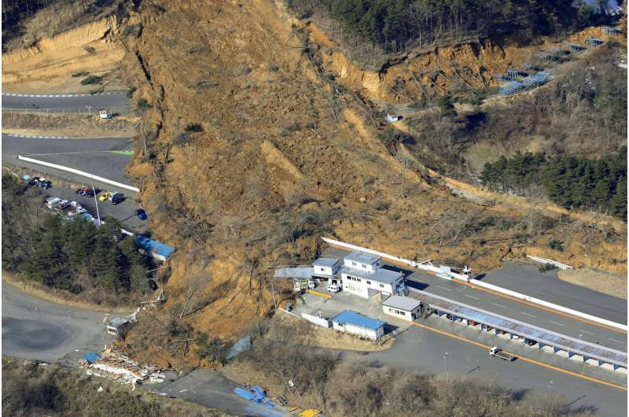

Fig 1.1 Landslide occurrence

Landslides happen when the ground beneath becomes unstable and starts to move. This can be due to a variety of reasons, including heavy rainfall, earthquakes, or even just the weight of the material on the slope itself.

12.65 of land areas are susceptible to landslides in India. Correct information regarding the causes of landslides is important to require timely preventive measures and guarantee safety.

**1.2 – What causes a landslide**

**1.2.1- Deforestation**

Deforestation can lead to increased incidences of landslides. This is because trees and other vegetation help to hold soil in place and prevent erosion. When these vegetative barriers are removed, the soil is made likely to be washed away by rain or floods.

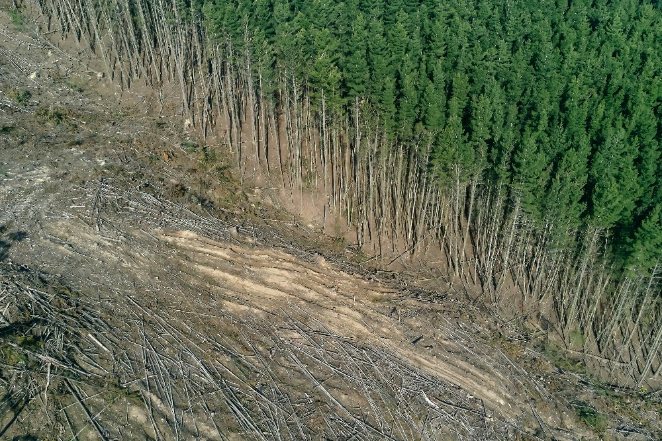

Fig 1.2 Deforestation

**1.2.2 – shifting cultivation**

Shifting cultivation is a type of agriculture in which farmers clear a piece of land, grow crops on it for a few years, and then move on to a new piece of land. This type of agriculture often leads to deforestation, as farmers need to clear new land for cultivation each time they move.

Deforestation can destabilize the land and make it more susceptible to landslides.

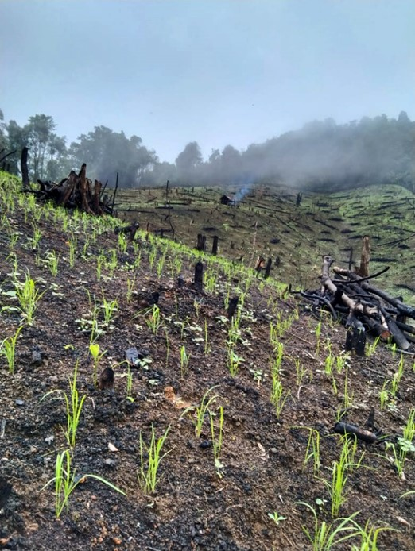

Fig 1.3Cultivation of shifting

**1.2.3- Heavy Rainfall and Earthquakes**

Landslides often occur during or after a heavy rainstorm, when the ground is already saturated with water and unable to absorb any more. They can also be triggered by an earthquake when the shaking loosens the soil and rocks on a slope.



Fig 1.4 Rainfall occurring on Hill

**1.2.4- Mining**

Landslides are often caused by natural disasters such as earthquakes, but they can also be caused by human activities, such as construction or mining.

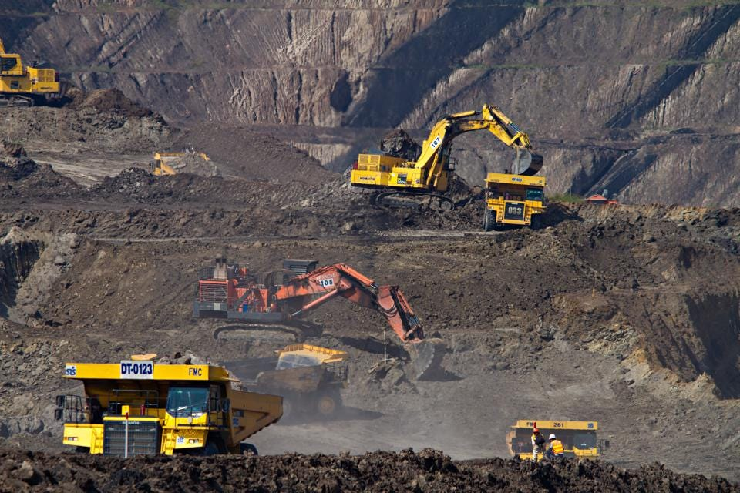

Fig 1.5 mining factory

**1.2.5- Urbanization**

Urbanization can lead to an increased risk of landslides in several ways. One is that the process of urbanization itself can destabilize slopes and create landslide hazards. This can happen when construction activity alters the drainage patterns of an area, when removal of vegetation exposes to erosion, or when changes in land use increase the weight or volume of material on a slope. In addition, urbanization can lead to changes in land cover that make it harder for rainfall to penetrate the ground, leading to more surface runoff and erosion. Urbanization can also increase the risk of landslides by creating a more impermeable surface that prevents water from slippering into the ground, leading to a build-up of water pressure that can destabilize slopes.



Fig 1.6 Urbanization of city

**1.3- Different types of Landslides**

1: Topples

2: Falls

3: Flows

Every landslide is described in the following paragraph.

**1.3.1- Topples: -**

This happens when huge masses of rock, debris, and the earth falls from a slope.

**1.3.2- Falls: -**

Falls happen when loads of soil, rock, and debris break from slopes and cliffs due to sudden movement. This can happen due to earthquakes and due to force of gravity.

**1.3.3- Flows: -**

In this type of landslide, the debris flow in a form of rapid mass movement. It contains loose soil, air, rock, and water and it flows downslope.

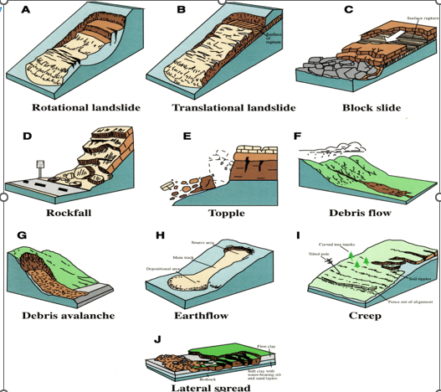

Fig 1.7 Types of landslides

**1.4- Impacts of landslides**

1: Mud, debris, and rocks fall in the form of slides from the slope throughout landslides. This restricts human movement and creates a traffic barrier on highways and railway lines.

2: We loss of human lives is also one of the severe effects

3: Landslides damage the homes, roads, and buildings of habitats.

4: It also additionally increases the danger of floods.

**1.5- Landslides vulnerable zones in India**

1: Uttarakhand

2: Sikkim

3: Darjeeling

4: Western ghats

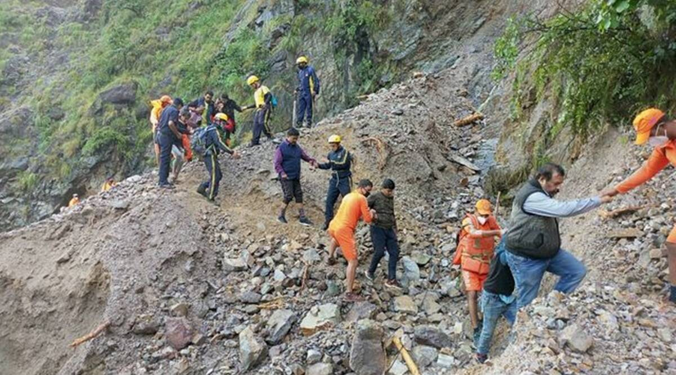

Fig 1.8 landslides occurrence in Nainital district

**1.6- Why use a landslide detection system?**

Landslides occur naturally so we cannot stop them. But we can predict landslides and there are different methods to detect landslides, one way to detect landslides is to use sensors that measure changes in the ground. These sensors can be placed along a slope that is prone to landslides. When the ground moves, the sensor will detect the movement and send a signal to a central system. The system can then analyze the data and provide information about the landslide.

In our landslide detection system, we will be using different kinds of sensors like soil moisture sensors and accelerometers. The soil moisture sensor will detect the moisture in the soil and the accelerometer will detect the calibration in the soil. We will combine these sensors and connect them to Arduino Uno for data processing. This will generate data and we will use this data to predict landslides. We will apply a regression algorithm to these data and then we can predict landslides.

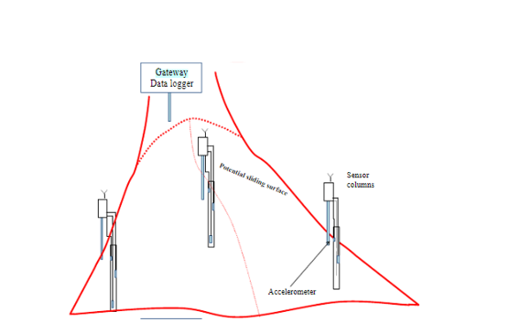

Fig 1.9 sensor setting

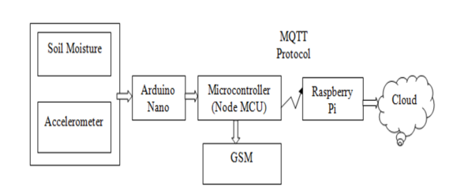

Fig 1.10 Block Diagram

**Chapter-2**

**Project Description**

**2.1- Purpose of the Project**

The main objective to implement this project i.e., Landslides detection and prediction using an IoT system is to solve and prevent naturally occurring disasters or calamities by giving information as early as by calculating the machine learning algorithm in the given data set.

There is various purpose to creating such an environment for reducing disaster in which the sensor senses the element and send the data quickly and various learning algorithm is used to give information to the people about the disaster. It is low-cost and easy to implement and can be used by the semi-skilled person.

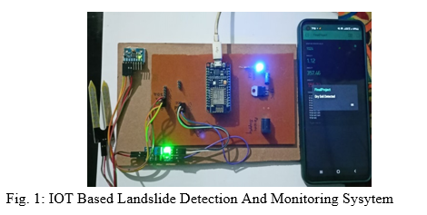

Fig -2.1 IOT Based Monitoring System

There is various method to detect landslides, mostly using three types:

1. Field survey method

2. Traditional remote sensing image processing method

3. Statistical and machine learning methods

Landslides prediction and detection relies on scientific method and data which will require the series of input from time series of data from the geographical and Environment. The author L Cheng describes in his article the Yolo model for landslides prediction and detection [2]. These data are collected from the various sensing satellite and Internet of things sensors that are embedded in the disaster sites. There are various devices which are embedded in the prone area, that are Raspberry pi, soil moisture sensors, etc.

**2.2 – Highlight of the project**

Landslides are the main headache and major Natural disaster which damages the human environment and social economic and Nature. Landslides occur mainly due to Heavy Raining and earthquakes. In this today’s world context, it also occurs due to climate change. To overcome this problem, we are using various IoT systems.

**2.2.1- Soil Moisture Sensor**

Landslides mainly occur due to heavy rainfall in the area. There are various types of soil present in our Environment and has their own unique property Some soil is loosely packed, and some are tight. Mainly landslides occur in loose soil. To know the property and quality of the soil where landslides occur, we required the sensor known as the soil moisture sensor. It checked the quality of the soil and retrieves the information from the soil and sends the data for processing we can analyze that data and detect and predict the natural disaster in the early stage.

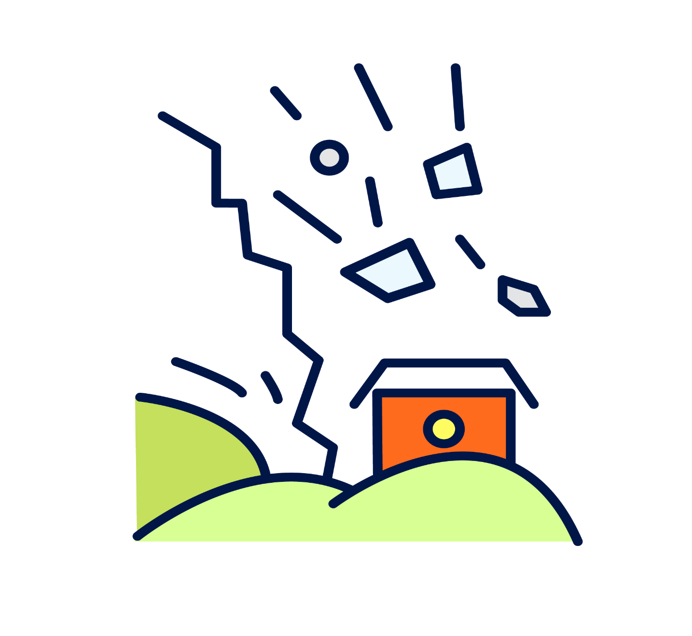

Fig 2.2 Animated photo of Landslides

**2.2.2 Arduino Uno**

Arduino Uno is the main component of this project’s landslide prediction and detection which will give a command to the sensor and the sensor start to retrieve the data from the component by sensing and sends it to the cloud for the processing which will be described in the below figure.

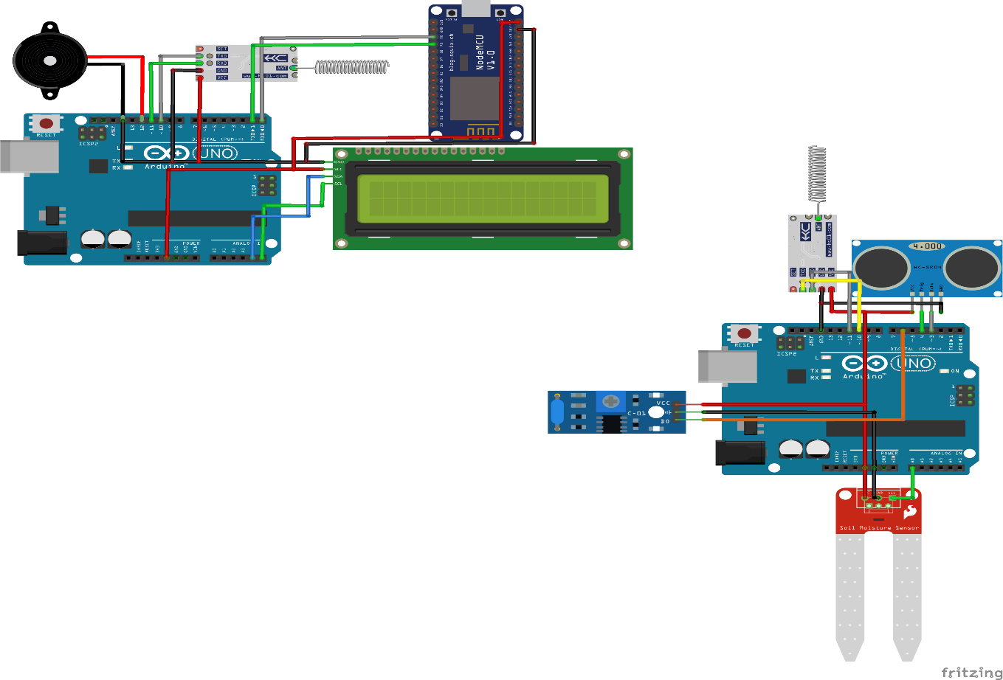

Fig 2.3 Diagram of Arduino connection in soil moisture sensor

**2.2.3- Jumper Wire**

The jumper is the type of wire which are used to connect the sensor and Arduino for their experimental purpose. It contains male-male and male-to-female pins in its last part to connect the instruments. It is easy to set up without soldering in the wire because it has a different pin to connect.

Jumper wires have different colors present in them. Many people supposed that it has a different function to give the result, but it doesn’t have anything to do. Its simple function is to make people visible about the wires nothing anything else.

There are various types of jumper wires-

1. Male-male
2. Male-to-female
3. Female-female

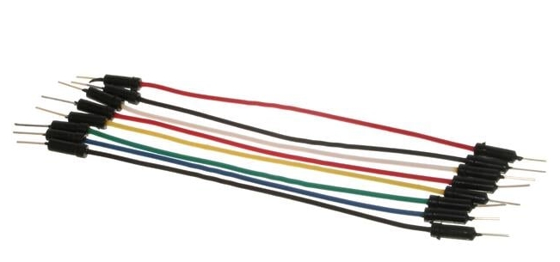

Fig 2.4 male-male wires

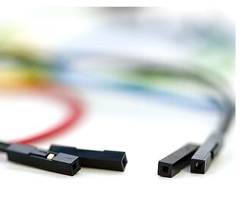

Fig 2.5 Female-Female wires

**2.2.4 - Arduino IDE**

It is open-source software that is used to upload and write the code for Arduino. It can support various operating systems like windows, macOS, and Linux. IDE is also known represented for Integrated Development Kit. The program is written in this ide also known for sketching. It has a. ino extension to save the file of the program. There is various icon present in it.

Some of them are

1. Tool bar
2. Menu Bar
3. IDE version

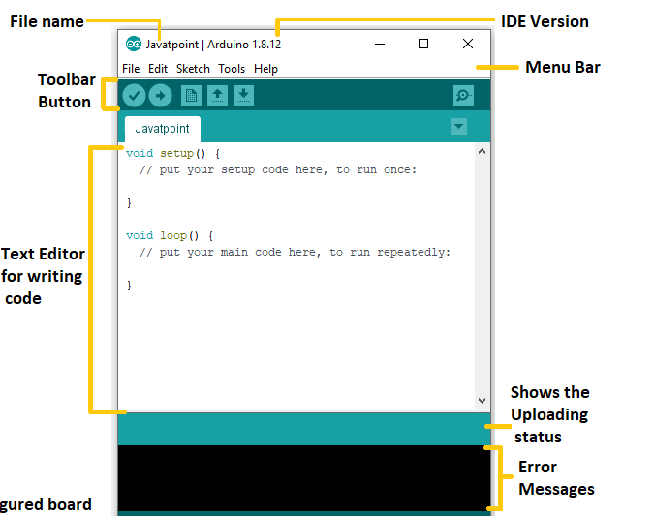

Fig 2.6 Arduino ide GUI

**2.2.4.1 - Tool Bar**

It shows the various types of tools that have different types of functions on IDE.

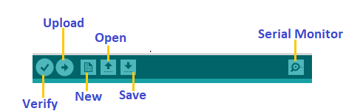

Fig 2.7 Tool bar diagram

**2.2.4.1.1 – Upload**

It is a special button on Arduino IDE which is used to compile the code and helps to run the code. It also helps to run the code to the connected device to give the result. It also requires the USB cable to connect the board and computer upload the code and fetch the result in the system or practical we perform.

**2.2.4.1.2 – Open**

It is used to open the user or existing file which we had created already. If we select the file present in the system and open it, it automatically opens in the existing window of the IDE.

**2.2.4.1.3 – Save**

This button is used to save the sketch or code which we had compiled or run in the system.

**2.2.4.1.4 - Serial Monitor**

This icon is used to monitor the result that we had performed in the system and give the result in Numeric and graph format. It looks like this given in the below figure:



Fig 2.8 serial monitor Icon

**2.2.4.2 – Menu Bar**

It contains various types of tools just as file, view, etc

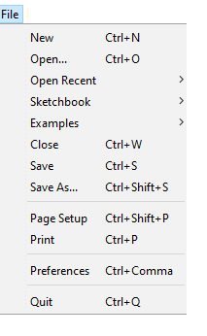

Fig 2.9 file view in Arduino

**2.2.4.3 – IDE Version**

It shows the version of the IDE at the Top of the IDE. It helps the user which generation of IDE he/she is using.

**2.2.5 – IoT Cloud**

It is a cloud that is like other clouds, and it is used in the online platform which makes it easy to create, delete and deploy the project. There are various versions of IoT cloud and have a subscription base plan for the customer to use it.



Fig 2.10 IoT cloud

There are various features of the IoT cloud. They are-

1: Auto-generate sketch

2: Device to Device communication

3: Over the Air updates

4: Trigger action on cloud

5: Sharing the Dashboard

6: Alexa Integration

7: Api Integration

**2.2.6 – Accelerometer**

It is a device or tool used in a different machine or in the IoT system to capture or measure the proper accelerometer of the device. It works on different frames as it has an x-axis and y-axis or z-axis. Different devices like cameras, cars, smartphones, etc use this type of technology to measure the accurate accuracy of the device. It is also used in various daily life tools. It helps in fitness. This device is very important because it helps to give the result of our surroundings. Its measuring unit have+-1%. It is an electronic sensor that is connected to a device that is used to measure the acting force on it.

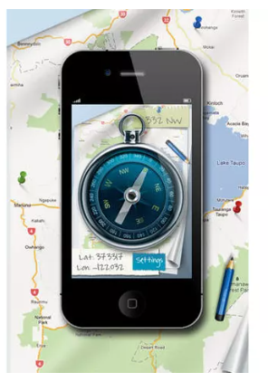

Fig 2.11 Accelerometer measuring in iPhone

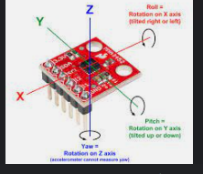

Fig 2.12 measuring the accelerometer by using coordinates

**2.3 – Problem Statement**

**IoT** is used in various fields of Technology and daily life. Technology includes Information Technology, Health care, Data science, Agriculture, etc. IoT mainly has the problem of security because it is a physical device and must implement outside of the human infrastructure and can get damaged by different types of calamities or by a human.

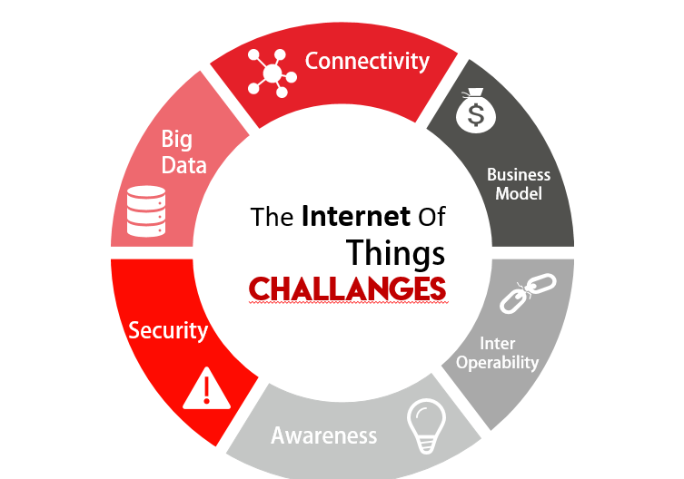

Fig 2.13 Problem diagram

**2.3.1 – Various Challenges Faced by IoT device**

**1:** **Scalability:** -

There are various IoT systems inter-connected in the Network and the network is huge. Different and huge data are being processed and analyzed in it, so it needs to be scalable. In today’s world scenario many devices are connected to the cloud or on the internet. It can capture various raw data and at first, these data are not properly managed (i.e., it is not useful). It should be managed properly by using big data and analyse the data and use in a real-world scenario. It should ensure the data it collected is accurate while analyzed or by performing various algorithms.

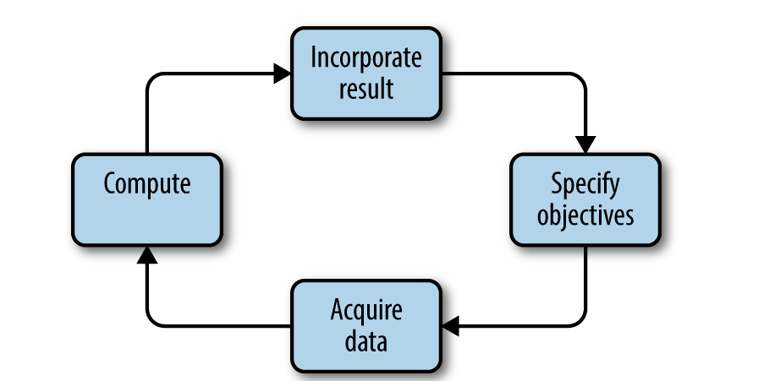

Fig 2.14 Scalability of IoT devices

**2:** **Security: -**

Security is a major concern in the IoT device and if it breaches then a huge loss to the industry or to the people who are using this technology. IoT device is connected via the internet and provides capture or collected data in the cloud. This data can be fetched by attackers by using different attacking methods. To secure this, we must implement various security not only physical but also logical, so that no one can breach our data and cannot detect the vulnerability in the system. Various security risks which can occur in IoT systems are authentication, authorization, confidentiality, integrity, etc. challenges to give the safety of the data to the user and provide privacy. Various companies use the CIA technique to provide security to the user by providing cloud facilities.

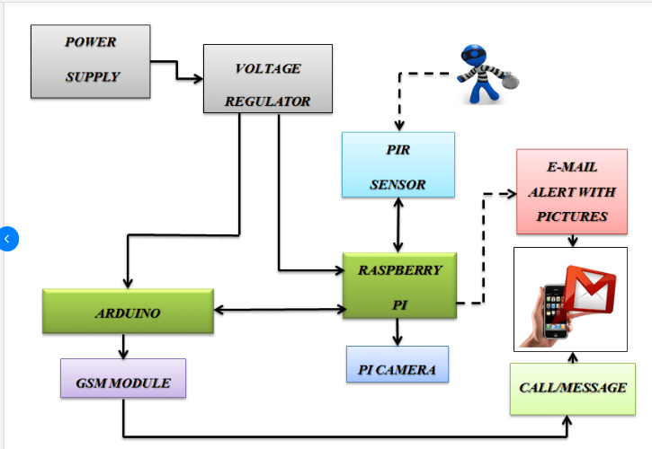

Fig 2.15 Block diagram of the security system of IoT

**3: Awareness: -**

IoT provides various awareness to people by providing potential in daily life. It is also not very much famous in this modern society. Many people don’t know about IoT systems, and they should be promoted from the grass root level so that many people can get benefit from this system, and we can develop our technology in remote areas too. Many start-ups don’t know the benefit of this technology and various industries don’t have the proper planning for this system. It can save us from various types of natural calamities and can maintain our health.

**4:** **Business model: -**

IoT is a type of technology that is capable to change the mode of various industries and it can transform the old types into digital. Those industries which are using manual systems in their daily routine then it can change it whole with digitalization.

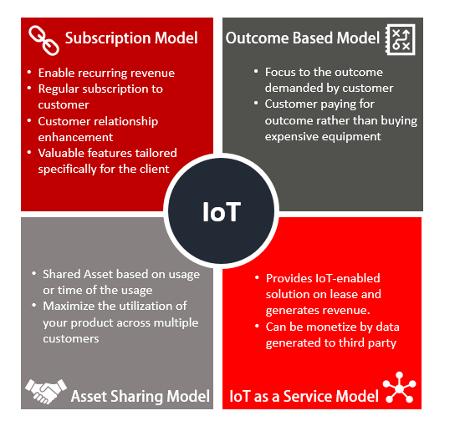

Fig 2.16 Plan of IoT system

**5:** **Connectivity: -**

It is the main challenge of this system because to implement an IoT system we need to connect to the internet to work on a regular basis and a power supply is also needed. This plays a very important role to transfer the packet of data from the sensor and helps to store that data in the cloud.

Connectivity uses various types of protocols to connect sensors to the system like Bluetooth, ZigBee, etc.

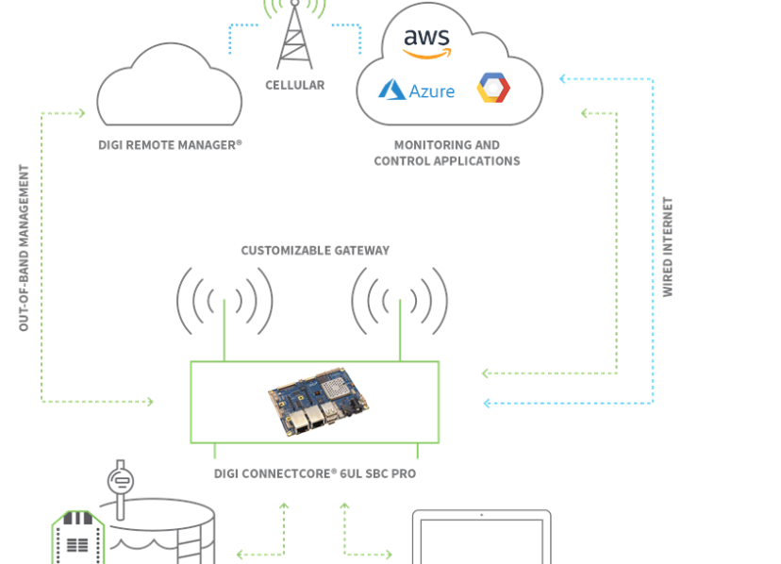

Fig 2.17 connectivity diagram

**6:** **Big Data: -**

Big data is mainly used to manage the data which is captured from IoT devices and perform various operations in it to make it useful to the user. Data can be structured, and unstructured, and different machine-learning algorithm is used to make it easy for the user. Big data is not as easy as we can understand. It is more complex to analyse the data we had seen or captured as it has an unstructured format.

**2.4- Special Feature**

**Machine learning** is an algorithm that is used to predict different data models. It is also the branch of artificial intelligence that always focused on to use of data and different algorithms to help humans in daily life.

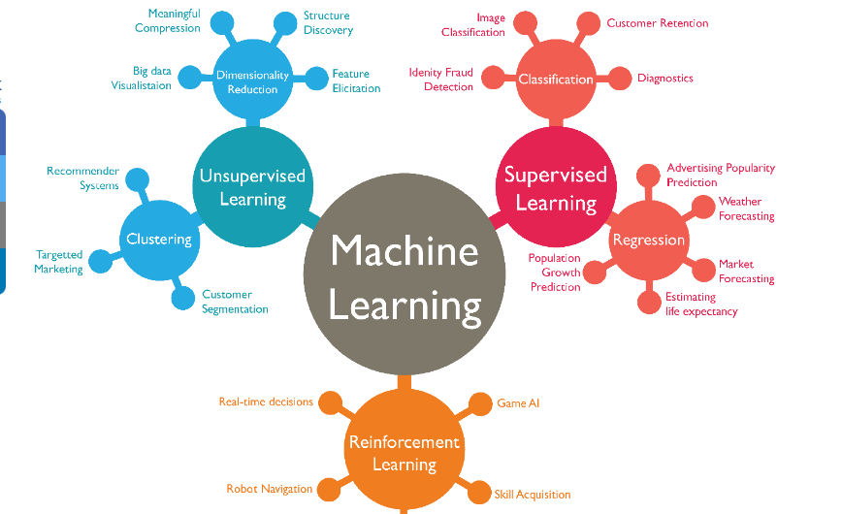

Fig 2.18 Machine Learning Algorithm

It is always important in an organization or in daily life because it shows the actual behaviors of the customer or model in the project. It also supports the development of different applications etc. various companies like Microsoft, Apple, Google, and Facebook use this algorithm to perform better and improve their quality for the user.

It contains various learning algorithms. Some of them are:

1: Supervised Learning

2: Unsupervised Learning

3: Reinforcement Learning

4: Semi-supervised Learning

**Chapter-3**

**Tools and Technology**

**1: Hardware component**

Hardware components are the most important in this project. All the implementation is done by hardware and its component. There is various hardware we are using in this project. They are described below.

**1.1: Soil moisture Sensor: -**

The soil moisture sensor is a type of sensor that is used to gauge the volumetric content of water within the soil. This sensor uses the property of soil such as electric resistance, and di-electric constant for measuring moisture.

Features of soil moisture sensors are: -

1: It always requires operating by using 5v power.

2: The current requirement to operate is <20mA.

3: It belongs to the analog category.

4: This sensor works on the temperature of 10 degrees to 30 degrees Celsius.

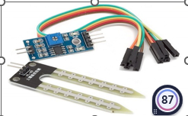

Fig 3.1 Soil moisture sensor diagram

This sensor consists of 4 pins that represent different functionality. They are: -

Vcc pin: This is used to get power for the sensor.

A0 pin: This is used to show the analog output.

D0 pin: This is used to get the digital output.

G0 pin: This is a ground pin.

We use this sensor by putting it into the ground and collecting the moisture present in the soil and calculating the different algorithms in it.

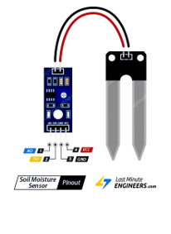

Fig 3.2 Showing pins of soil moisture sensor

**1.2: Accelerometer: -**

An accelerometer is a sensor device that is used to calculate or measure the acceleration forces, forces can be static i.e., the continuous force of gravity. This is used to measure the proper acceleration which is the acceleration of the body in its own continuous rest frame. It is also used to measure or calculate the different types of variations.

It also works on the principle of the moment or the vibration of the body which is using an electromagnetic sensor. It also even senses the vibration on a micro-scale. The body sense has a vibration, and it converts it into the piezoelectric effect which occurs when energy is generated due to pressure and stress, that pressure is converted into electric voltage.

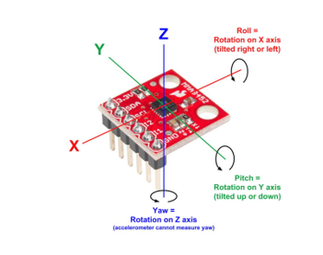

Fig 3.3 Working principle of Accelerometer

The velocity which is present in the material is calculated by using that voltage only. The force is caused by the vibration or a which are being changed in motion causes the squeeze of the mass in the piezoelectric material which is used to produce an electric charge that is proportional to the force exerted upon it.

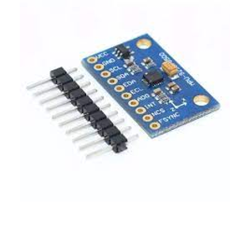

Fig 3.4 Accelerometer

It is used in different sectors of technology and industry. A highly sensitive Accelerometer is used in Modern aircraft and missiles. Vibration in the machine is also monitored by using this type of sensor. They are also used in mobile phones, tablets, and digital cameras.

**1.3: Arduino Nano: -**

It is a special board consisting of various same and similar connectivity and special feature of Arduino Uno board, but it is smaller in form and has equipped with 30 male I/O Headers that can be programmed by using Arduino IDE. It has various models in the market, but the commonly used Arduino Nano is ATmega328p or ATmega628 microcontroller. This board or microcontroller is used for breadboard use and has the feature of soldered graders for all pins which allows you to connect or attach the board easily.

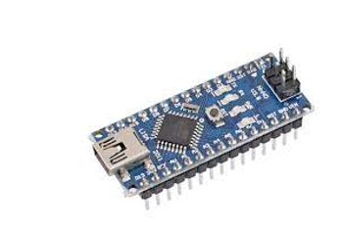

Fig 3.5 Arduino Nano

It has a special feature. They are:

1: It always operates in 5v

2: It has input voltage in the range of 7v to 12v

3: There is a total of 22 input and output pin

4: Analog i/o pin are 6 from A0 to A5

5: There are 14 digital pins

6: It consumes the power of 19mA

7: It has a weight of 7g

8: The size of the printed circuit board on Arduino Uno is 18 X 45 mm

9: It has an SRAM of a capacity of 2GB.

There is various method to give power to the Arduino Board. We can also use the Mini-B USB-type connector. If it is not available, then we must provide a 5v supply through a 5v pin.

There are altogether 30 pins in the Arduino Nano where 22 pins are attached or associated with the input function and output function. There are 14 pins that are true digital I0 and 8 pins are connected to the Analog system. A very important function of analog pins is they can also be functional or configured as Digital Input Output pins if They are required.

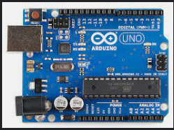

Fig 3.6 Arduino Nano

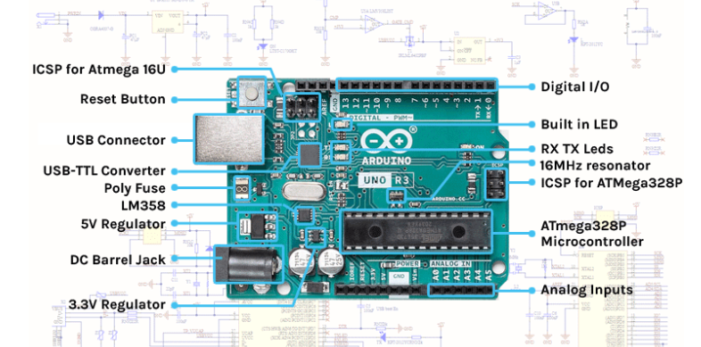

Fig 3.7 Showing the parts of Arduino Uno

**1.4 – Raspberry pi: -**

Raspberry pi is one of the best micro-controllers at the current time and is developed by the Raspberry pi foundation in association with Broadcom which is a United Kingdom charity foundation that aims to educate people in the field of computing. It has a series of single-board computers which provide low-cost, high-performance, and is the size of a small pocket carrying a credit card.

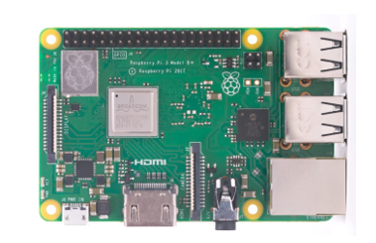

Fig 3.8 Raspberry pi Diagram

In the current time, all over the world People are utilizing their time to learn Raspberry pi programming skills, started to build hardware projects, and do automation and various application. It has various qualities and has a cheap price that can run on a different platform, and it is also known as platform dependent. It has an OS like Unix and provides the general purpose of input-output pins to allow us to control the function of electrical components and all components are used in most fields of IoT. Various sensors which we need to connect to the Raspberry can connect directly to the GPIO with the help of a jumper wire shows to connect with the outside world.

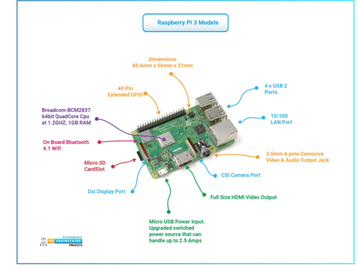

Fig 3.9 component of a Raspberry pi

**1.5: Jumper wire: -**

The jumper is the type of wire which are used to connect the sensor and Arduino for their experimental purpose. It contains male-male and male-to-female pins in its last part to connect the instruments. It is easy to set up without soldering in the wire because it has a different pin to connect.

Jumper wires have different colors present in them. Many people supposed that it has a different function to give the result, but it doesn’t have anything to do. Its simple function is to make people visible about the wires nothing anything else.

There are various types of jumper wires-

1. Male-male
2. Male-to-female
3. Female-female

Types of jumper head shapes are:

1: Square head

2: Round Head

A male plug in a jumper wire is referred to as a plug and a female connector is known as a jack.



3.10 Female-Female wire



Fig 3.11 Male-Male Wire

**1.6-ESP8266 WIFI MODULE: -**

It is also the main component of an IoT system and has a low-cost Wi-Fi chip that is built into the TCP/IP protocol in the networking and has the availability of microcontroller capacity. ESP8266 WIFI MODULE is an integrated chip that consists of a self-contained soc that has the TCP/IP protocol stack that can connect or give access to any microcontroller to the Wi-Fi Network device. We can also simply connect to our Arduino device and can access the Wi-Fi network in the system.

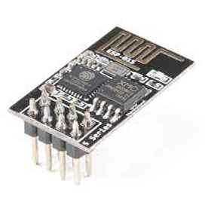

Fig 3.12 ESP8266 WIFI MODULE

Wireless internet access can be added to any of the microcontroller device or the system which has simple connectivity through the UART interface. It is very efficient board having low cost and popular is huge among the community and has powerful processing and storage capacity allowed to the integrated with the various sensors through it GPIO.

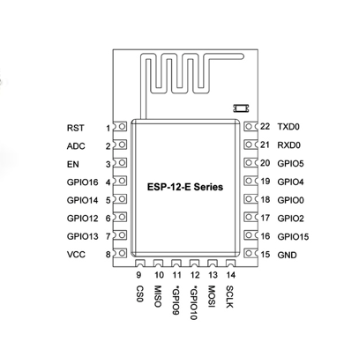

Fig 3.13 Various pins of the Esp8266 module

There is various feature:

1: Has a very low power integrated 32-bit MCU

2: Has 10-bit ADC in the module

3: Has a TCP/IP protocol stack in the module to connect to Wi-Fi

4: Always supports antenna diversity in the module

5: Has support of WPA/wpa2 with 2.4 GHz

6: Have a deep sleep power <10uA

7: Have a Power down leakage current<5uA

8: Operating range temperature -40c~125c

**1.7: Node MCU: -**

It is a low open-source IoT device platform. It is based on the firmware an ESP8266 WIFI module. Node MCU is also implemented in c language and is also layered on the Espressif NON-OS software development kit. The name NodeMCU combines the node of MCU speaking the term which refers to the firmware rather than which is associated development kit. There are two things i.e., firmware and prototyping board design which are open source. They are easily available on the internet. They use a Lua scripting language whereas prototyping hardware is usually used in a circuit board functioning as a dual in-line package. It’s hardware design is open for editing, modification, and building.

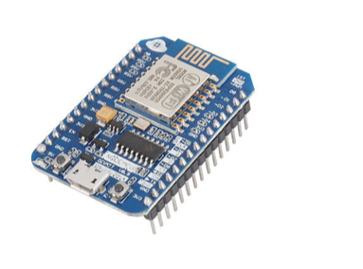

Fig 3.14 Node MCU

Features of Node MCU are:

1: It is used in USB-micro-USB port power for programming and debugging

2: It uses a power consumption of 5v through a Micro USB port

3: It has dimensions of 49 x 24.5 x 13mm

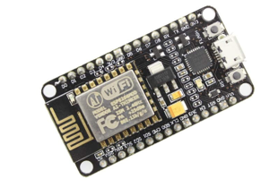

Fig 3.15 Node MCU Different module

**2: Software Component: -**

A software component is used to implement or give commands to the hardware sensor to fetch the result.

**2.1: Arduino IDE: -**

It is open-source software that is used to upload and write the code for Arduino. It can support various operating systems like windows, macOS, and Linux. IDE is also known represented for Integrated Development Kit. The program is written in this ide also known for sketching. It has a. ino extension to save the file of the program. There is various icon present in it.

Some of them are

1. Tool bar
2. Menu Bar
3. IDE version



Fig 3.16 Arduino ide GUI

**Chapter- 4**

**Implementation and Modules**

**Modules: -**

**4.1: Soil Moisture Sensor: -**

A soil moisture sensor is a type of sensor which is used to sense the moisture quality of soil and prevent landslides by collecting the water on the surface of the soil.

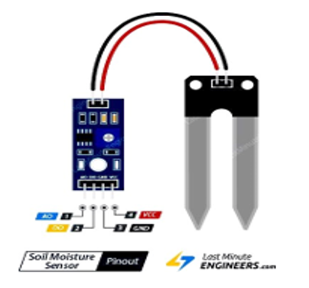

Fig 4.1 soil moisture sensor

**4.2: Arduino Nano: -**

It is a special board consisting of various same and similar connectivity and special feature of Arduino Uno board, but it is smaller in form and has equipped with 30 male I/O Headers that can be programmed by using Arduino IDE. It has various models in the market, but the commonly used Arduino Nano is ATmega328p or ATmega628 microcontroller. This board or microcontroller is used for breadboard use and has the feature of soldered graders for all pins which allows you to connect or attach the board easily.

There is various method to give power to the Arduino Board. We can also use the Mini-B USB-type connector. If it is not available, then we must provide a 5v supply through a 5v pin.

There are altogether 30 pins in the Arduino Nano where 22 pins are attached or associated with the input function and output function. There are 14 pins that are true digital I0 and 8 pins are connected to the Analog system. A very important function of analog pins is they can also be functional or configured as Digital Input Output pins if They are required.



Fig 4.2 Parts of Arduino

**4.3: Jumper Wire: -**

The jumper is the type of wire which are used to connect the sensor and Arduino for their experimental purpose. It contains male-male and male-to-female pins in its last part to connect the instruments. It is easy to set up without soldering in the wire because it has a different pin to connect.

Jumper wires have different colors present in them. Many people supposed that it has a different function to give the result, but it doesn’t have anything to do. Its simple function is to make people visible about the wires nothing anything else.



Fig 4.3 Female- Female wire

**4.4: Excel Sheet: -**

Excel sheet is a Microsoft software which is used to store the data which we had captured and do some logic from that we plot the graph. It is open-source software that we can use freely for those who are using windows and it doesn’t allow another user to do task init.

**4.5: Arduino IDE: -**

It is open-source software that is used to upload and write the code for Arduino. It can support various operating systems like windows, macOS, and Linux. IDE is also known represented for Integrated Development Kit. The program is written in this ide also known for sketching. It has a. ino extension to save the file of the program. There is various icon present in it.



Fig 4.4 Arduino GUI Interface

**Implementation: -**

**Screen sort of project:** -

In this project, we made a module with the help soil moisture sensor, Arduino nano, and jumper wire and implement it to capture the data of moisture that is present in the soil.

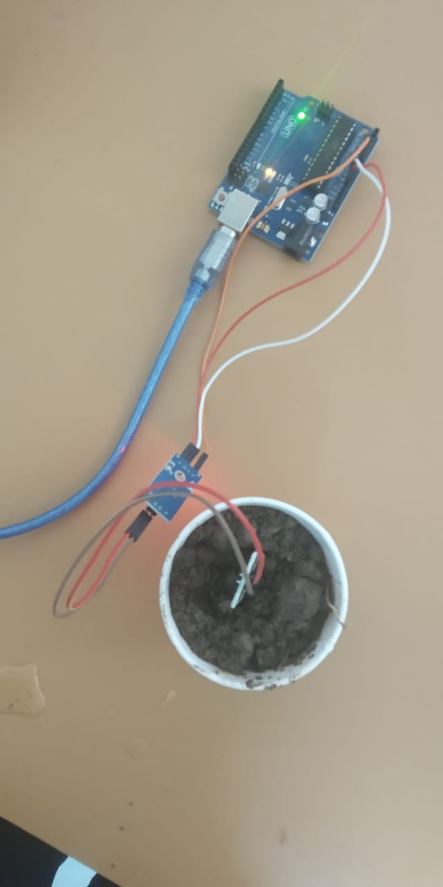

Fig 4.5 A working module of the project

After implementing the module, we had given the command to the sensor using Arduino ide and sent a request to capture the data of moisture which are present in the soil. This command or program is written in the format of c and c++. This is also known as the sketch.

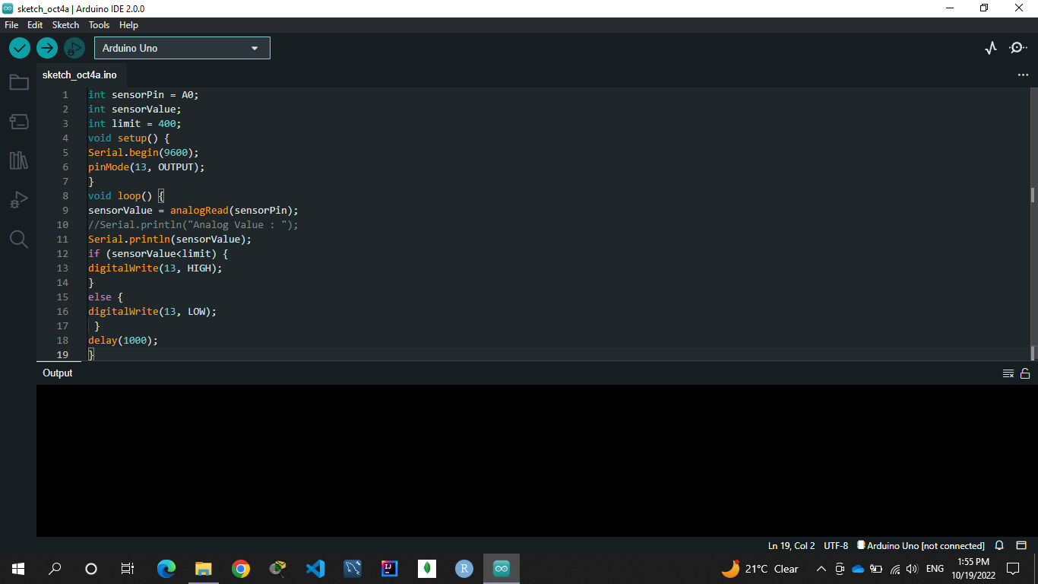

Fig 4.6 Arduino program

After performing all the implementation it’s time to capture the data in the excel file by adding some amount of water in the soil to implement the machine learning algorithm.

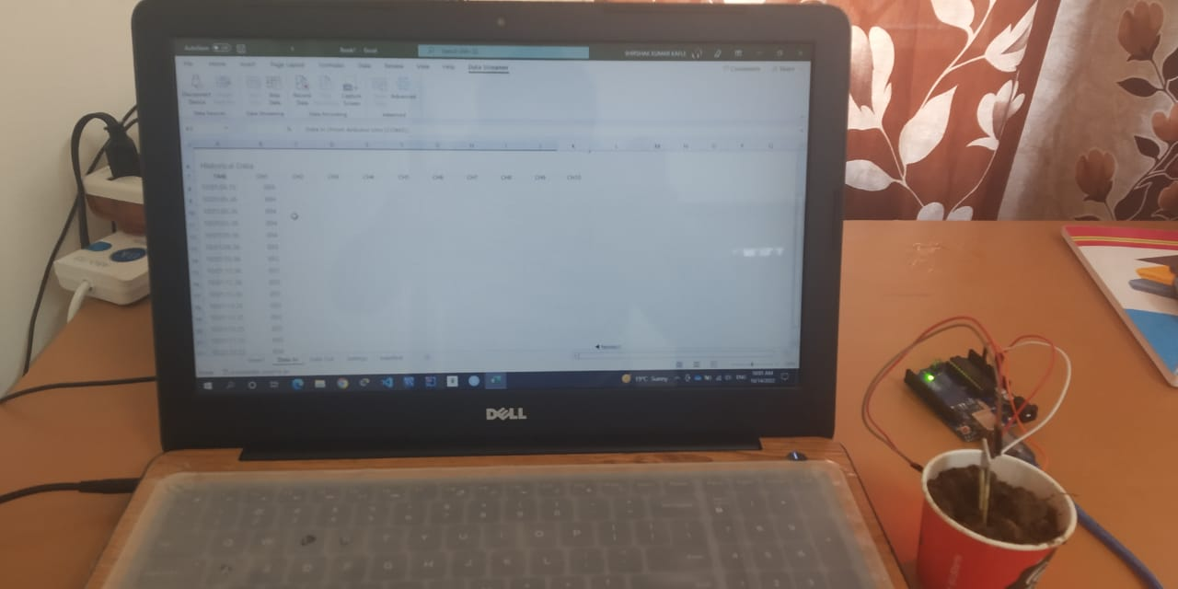

fig 4.7 Capturing the data in the Excel sheet

Here, we dipped the soil moisture sensor into the soil and added the water after some interval of time, so that we can get a different reading of data. All the instruments are connected to each other.

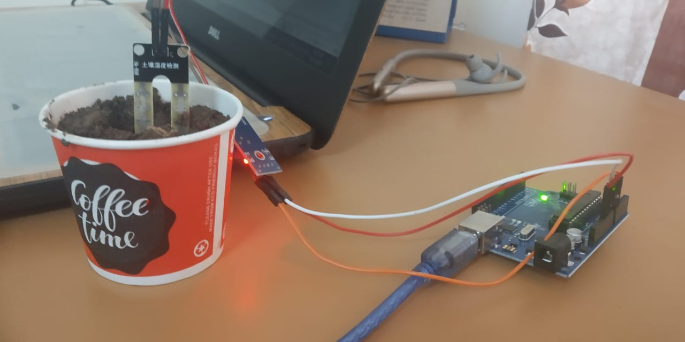

Fig 4.8 Soil moisture sensor in action with Arduino

After all the data and water are added the data which is shown in the output screen should store for further processing and stored in an Excel sheet. This data can be imported with the help of a data streamer which is an extension of MS- excel.

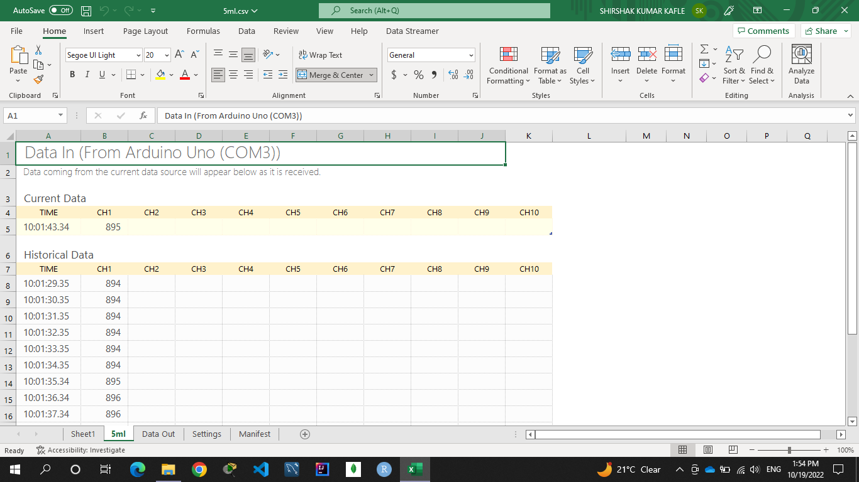

Fig 4.9 Data is Importing to store

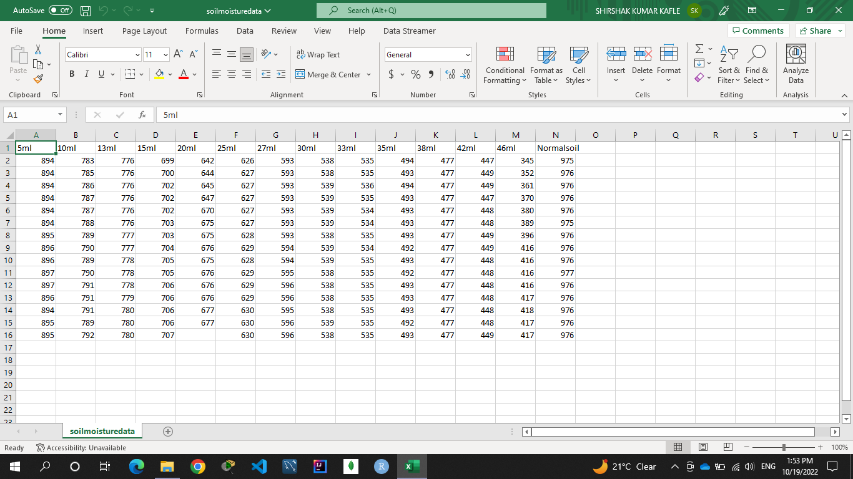

Fig 4.10 Data are extracted by adding water at some interval of time

After doing all these implementations we need to plot a graph to visualize the data. There is various plotting method to visualize the data.

They are:

1: Scatter plot

2: Histogram

3: Bar Plot

4: Pie-chart

We try to show the data in the bar graph and pie chart to the people. From that, they can easily understand the nature of data, and also we can find the outliers of the data and can easily remove those outliers by implementing various machine learning models.

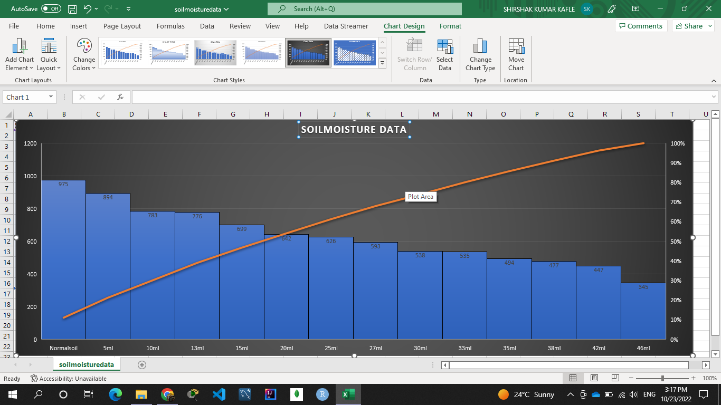

Fig 4.11 Bar Plot

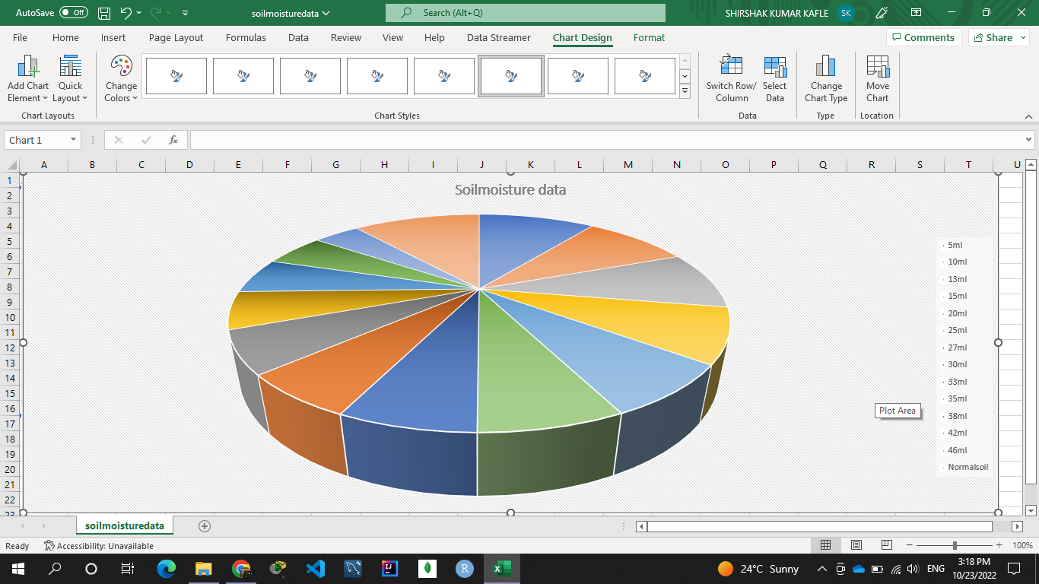

Fig 4.12 Pie-chart plot

After doing all these activities to the data we need to apply the machine learning Algorithm to get the result of the data to predict the landslide.

All these models are written in R-programming language and it is easy to visualize the data and easy to implement.

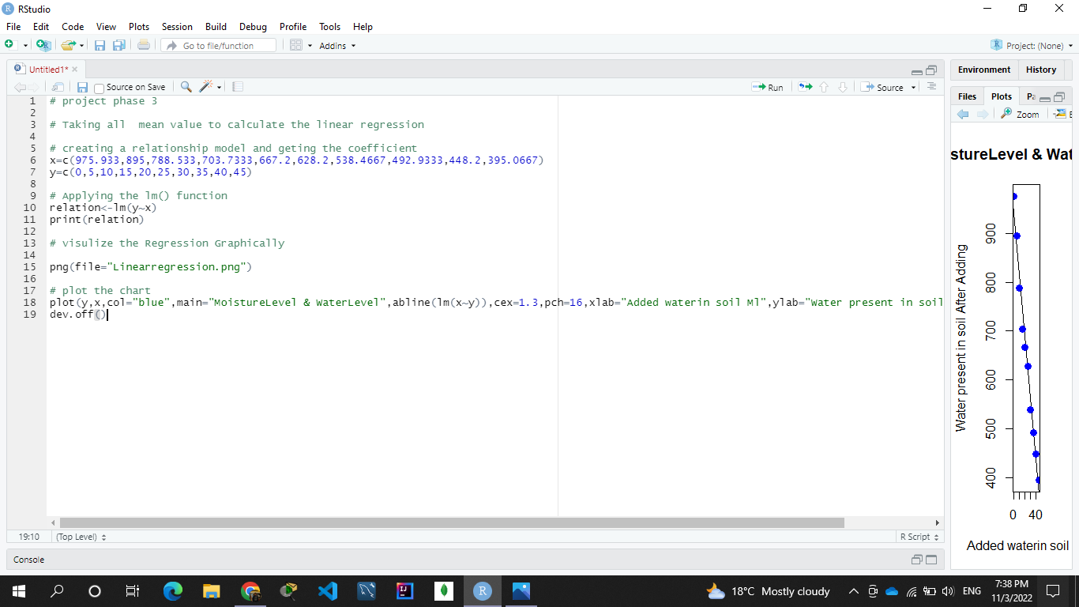

Fig 4.13 Machine learning Regression model

Linear Regression model is applied in it because it is very much effective for one dependent variable and to find an independent variable.

Its formula is y=mx+c.

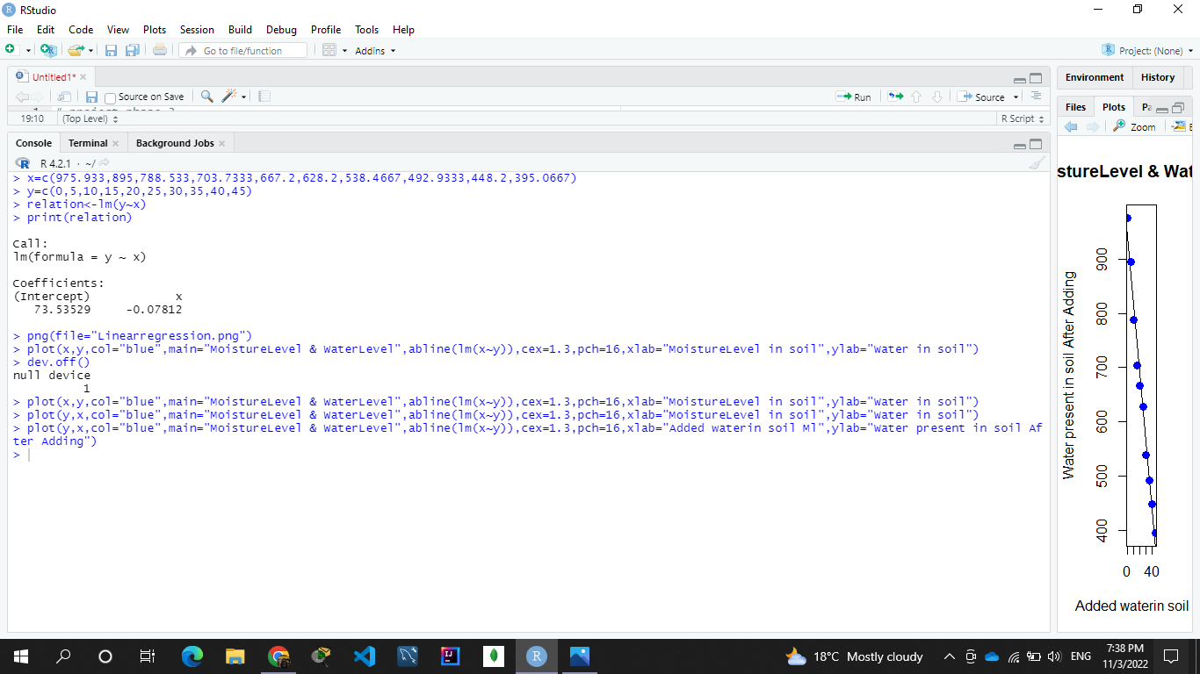

Fig 4.14 Implementation of Liner Regression

Intercept is 73.53529 and x is -0.07812

Graph is

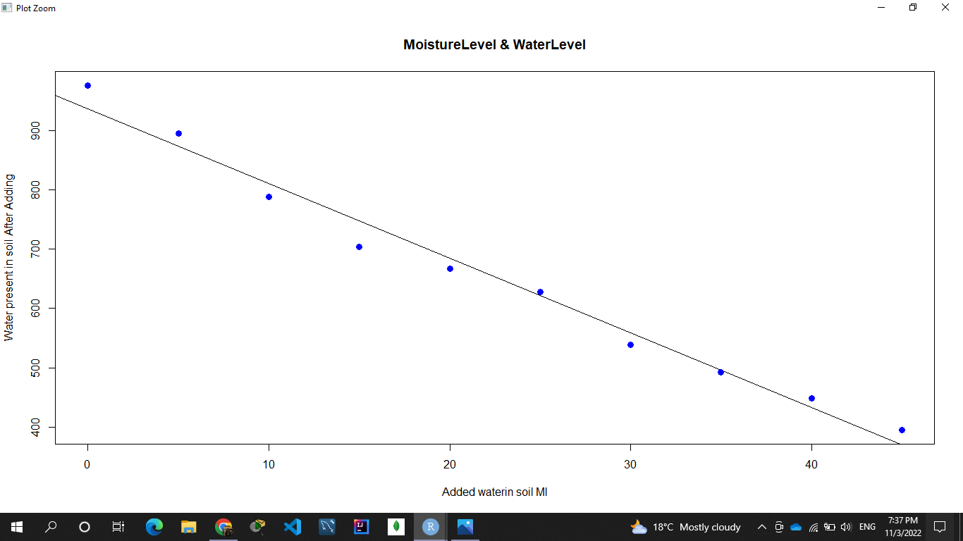

Fig 4.15 Graph of Liner Regression

**Working principle: -**

The below diagram shows the working principle of our project. First, we need to have a hardware and software interface where we need to connect our sensors like (Soil Moisture Sensor and Accelerometer). Data collected from the sensor should be perfect, so we need to store that data and processed it to get the result and send it to the software interface to take the decision. The sensor collects the data from the sites where we want to detect the information and sends the data for processing when data are being processed that data are sent to the cloud for storage and Stored data are analyzed in the cloud and it’s ready to prediction and sent to the web services for information

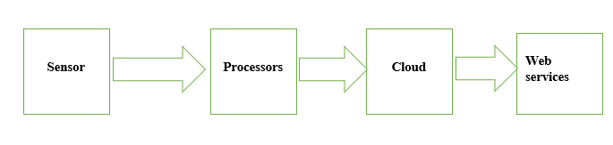

Fig 4.16 working module of cloud

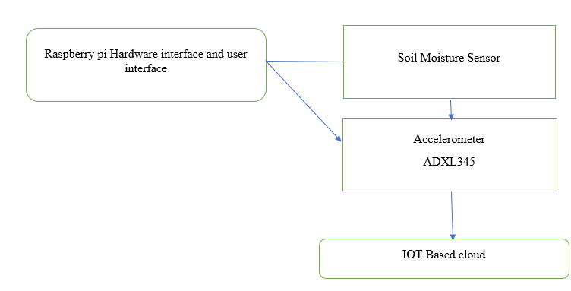

Fig 4.17 working module of a project

**Chapter-5**

**Conclusion**

**Conclusion of the project: -**

1. Landslides are very dangerous Natural disaster because it occurs suddenly and can cause serious damage in the area where it occurs. To prevent this, we should have a proper plan to detect and prevent it.
2. There are various Models to detect, and we must choose the best one for proper examination and understanding of the fundamental aspect of landslides.
3. Although, it can depend on the model we are using we need to find and select the complexity of the geographical area to predict the accurate result.
4. If we collect data from the sources but we must analyze that data properly so that we can prevent the disaster.
5. Architecture of the model should be made correctly so that it can collect better results.
6. Sensor should be connected well enough to give the result.
7. These data are not 100% correct so we need also more focus on our daily prevention.

References:

1: Mohan, Amrita, et al. "Review on remote sensing methods for landslide detection using machine and deep learning." *Transactions on Emerging Telecommunications Technologies* 32.7 (2021): e3998.

2: Terzis, Andreas, et al. "Slip surface localization in wireless sensor networks for landslide prediction." *Proceedings of the 5th international conference on Information processing in sensor networks*. 2006.

3: Mehta, Prakshep, et al. "Distributed detection for landslide prediction using wireless sensor network." *2007 First International Global Information Infrastructure Symposium*. IEEE, 2007

4: Yu, Zhao, et al. "Distributed detection in landslide prediction based on Wireless Sensor Networks." *World Automation Congress 2012*. IEEE, 2012.

5: Ramesh, Maneesha V., Sangeeth Kumar, and P. Venkat Rangan. "Wireless Sensor Network for Landslide Detection." *ICWN*. 2009.

6: Li, X., and L. M. Zhang. "Development of wireless sensor node for landslide detection." *Landslides and Engineered Slopes. From the Past to the Future, Two Volumes+ CD-ROM*. CRC Press, 2008. 1227-1232.

7: Singhroy, Vern. "Satellite remote sensing applications for landslide detection and monitoring." *Landslides–disaster risk reduction*. Springer, Berlin, Heidelberg, 2009. 143-158.

8: Chi, Kwang-Hoon, No-Wook Park, and Kiwon Lee. "Identification of landslide area using remote sensing data and quantitative assessment of landslide hazard." *IEEE International Geoscience and Remote Sensing Symposium*. Vol. 5. IEEE, 2002.

9: Bopche, Litesh, and Priti P. Rege. "Feature-based model for landslide prediction using remote sensing and digital elevation data." *Advances in signal and data processing*. Springer, Singapore, 2021. 299-312.

10: Bopche, Litesh, and Priti P. Rege. "Feature-based model for landslide prediction using remote sensing and digital elevation data." *Advances in signal and data processing*. Springer, Singapore, 2021. 299-312.

11: Mantovani, Franco, Robert Soeters, and C. J. Van Westen. "Remote sensing techniques for landslide studies and hazard zonation in Europe." *Geomorphology* 15.3-4 (1996): 213-225.

12: Lai, Jhe-Syuan, and Fuan Tsai. "Improving GIS-based landslide susceptibility assessments with multi-temporal remote sensing and machine learning." *Sensors* 19.17 (2019): 3717.

13: Lee, S. A. R. O. "Application of logistic regression model and its validation for landslide susceptibility mapping using GIS and remote sensing data." *International Journal of remote sensing* 26.7 (2005): 1477-1491.

14: Kotta, Herry Z., et al. "Wireless sensor network for landslide monitoring in Nusa Tenggara Timur." *TELKOMNIKA (Telecommunication Computing Electronics and Control)* 9.1 (2011): 9-18.

15: Shukla, S. K., et al. "Real-time monitoring system for landslide prediction using wireless sensor networks." *International Journal of Modern Communication Technologies and Research* 2.12 (2014): 265744.

16: Motakabber, S. M. A., M. I. Ibrahimy, and F. Anwar. "Wireless Sensor Network for Landslide Monitoring." *proceedings of the 3rd International Conference on Geotechnique, Construction Materials and Environment, Nagoya, Japan*. 2013.

